CSE 4165 / CSE 465
Web Programming — Mid Exam Mastery Guide
Pattern Analysis · Syntax Cheat Sheet · Fall'25 Solved Paper · Full Prep Guide
Built from 5 real UIU mid-exam papers: Spring'25, Summer'25, Spring'26 (Slot 1 & 2), Fall'25
Prepared for United International University · Dept. of CSE

Table of Contents

Part 1 — Question-Making Pattern (2025–2026)

1.1 Exam Format (Constant Across All Terms)
Every CSE 4165/465 Web Programming mid exam analyzed — Spring'25, Summer'25, Spring'26 Slot 1, Spring'26 Slot 2, and Fall'25 — follows an identical blueprint:
Property | Value
Total Marks | 30
Duration | 90 minutes
Number of Questions | 2 (Q1 and Q2)
Marks per Question | 15 + 15
Question type | Pixel-mockup replication (screenshot with annotated hex colors)
Deliverable | index.html + style.css (no JavaScript required)
Tools allowed | Pure HTML5 + CSS3 only — no frameworks (no Bootstrap/Tailwind)

1.2 The Core Testing Pattern
Each question gives a full-color UI screenshot (a real product-style mockup: landing page, dashboard, sign-in screen, job board, dashboard app, etc.) with red arrows pointing at elements and their exact hex color codes written beside them. You are NOT given the HTML/CSS — you must:
- Reconstruct the exact page structure using semantic HTML tags (header, nav, section, main, aside, footer).
- Match layout using Flexbox and/or CSS Grid (never floats, never absolute-positioning-heavy layouts).
- Apply the exact hex colors shown by the arrows to the correct elements (background, text, border, or icon fill).
- Reproduce spacing, rounded corners, shadows, and typography sizes as closely as possible by eye.
- Make it reasonably responsive (a @media query block is expected but lightly graded).

1.3 Q1 vs Q2 — Two Distinct Themes
Question | Typical Theme | Seen In
Q1 | Marketing / landing page: navbar + hero section + pricing or feature cards + CTA buttons | Spring'25 Q1 (UIU Info Desk), Spring'26 Slot1 Q1 (Admin Dashboard), Fall'25 Q1 (ProConnect)
Q1 (alt) | Split-screen auth/sign-in page: quote panel + form panel | Spring'25 Q2 (Sign In)
Q2 | Application dashboard: sidebar/topbar + stat cards + grid of content cards + progress bars | Summer'25 Q1 (Learning Hub), Spring'26 Slot1 Q2 (CareerHub), Spring'26 Slot2 Q1 (Cloud Dashboard), Fall'25 Q2 (Dashboard)
Q2 (alt) | Registration / listing page: sidebar + table + form | Summer'25 Q2 (Course Registration), Spring'26 Slot2 Q2 (Book Share Hub)
Takeaway: expect one "marketing/auth" style page and one "dashboard/app" style page in every paper. Master both templates and you can answer any variant.

1.4 Emphasis Chart — Component Frequency Across All 5 Papers (2025–2026)
This table shows how often each UI component/pattern appeared across the 10 questions (5 papers × 2 questions), ranked by emphasis. Use it to prioritize practice.
UI Component / Pattern | Times Seen | Emphasis
Top navbar (flex, logo + links) | 10 / 10 | Very High
Card grid (grid-template-columns / flex-wrap) | 9 / 10 | Very High
Buttons with colored background + border-radius | 10 / 10 | Very High
Form inputs (text/email/password) with placeholder | 6 / 10 | High
Sidebar layout (fixed-width flex child) | 5 / 10 | High
Progress / stat bars (nested div width:%) | 3 / 10 | Medium
Table (thead/tbody course or data listing) | 2 / 10 | Medium
Tag/badge pills (small rounded background labels) | 4 / 10 | Medium
Avatar circle (border-radius:50%) | 3 / 10 | Medium
Split-screen two-panel layout (auth pages) | 1 / 10 | Low
Linear gradients as backgrounds | 4 / 10 | Medium
Checkbox / filter groups | 2 / 10 | Low
Footer bar | 2 / 10 | Low
Responsive @media breakpoint | 10 / 10 | Very High (always required)

Part 2 — Most-to-Least Repeated Syntax (Data-Driven)
Counted directly from all 8 real solution files (index.html + style.css pairs) across Spring'25, Spring'26 Slot 1 & 2, and Summer'25. Numbers = total occurrences.

2.1 HTML Tags — Most to Least Used
Tag | Count | Typical Use in These Exams
<div> | 111 | Generic wrapper for every card/section/layout box
<a> | 68 | Nav links, buttons styled as links, CTAs
<p> | 66 | Body text, descriptions, labels, prices
<span> | 41 | Inline color-highlighted words, icons, badges
<input> | 25 | Form fields: text, email, password, checkbox
<label> | 19 | Form field captions, checkbox labels
<h2> | 18 | Section titles (card headings, panel titles)
<button> | 15 | Submit / action buttons
<h3> | 15 | Sub-headings inside cards/panels
<section> | 14 | Major page regions (hero, grid, panel)
<nav> | 10 | Navigation link groups
<header> | 6 | Top navbar wrapper
<td> / <th> | 6 / 3 | Table data / header cells
<main> | 5 | Primary content wrapper
<h1> | 5 | Page/section main heading
<aside> | 4 | Sidebar regions
<option> | 4 | Dropdown/select choices
<form> | 3 | Sign-up / registration / filter forms
<textarea> | 2 | Multi-line input (notes/descriptions)
<footer> | 2 | Page footer bar
<table>/<thead>/<tbody> | 1 each | Data listing tables
<blockquote>, <strong>, <select> | 1 each | Quotes, bold emphasis, dropdowns

2.2 HTML Attributes — Most to Least Used
Attribute | Count | Purpose
class | 280 | Hook for nearly all CSS styling (BEM-ish naming: .card, .btn-x)
href | 76 | Link targets (almost always "#" placeholder in exams)
type | 28 | Input type: text / email / password / checkbox / submit
placeholder | 14 | Grey hint text inside inputs
lang / charset / name / content / rel / initial-scale | 8 each | Boilerplate <head> meta tags — identical in every file
style | 4 | Only used for one-off inline width:X% on progress bars
rows | 2 | Textarea height control

2.3 CSS Properties — Most to Least Used
Property | Count | Category
font-size | 111 | Typography
color | 98 | Color
background | 91 | Color/Background
padding | 77 | Box Model
display | 68 | Layout
margin-bottom | 60 | Box Model
font-weight | 54 | Typography
border-radius | 49 | Border
gap | 35 | Flexbox/Grid
align-items | 24 | Flexbox
justify-content | 24 | Flexbox
flex-direction | 23 | Flexbox
width | 21 | Box Model
border | 20 | Border
grid-template-columns | 16 | Grid
text-align | 15 | Typography
max-width | 15 | Box Model
margin | 14 | Box Model
text-decoration | 12 | Typography
cursor | 11 | Interaction
font-family | 10 | Typography
margin-top | 10 | Box Model
flex | 9 | Flexbox
box-sizing | 8 | Box Model (always border-box via *{})
min-height / height | 7 each | Box Model
border-bottom | 6 | Border
line-height | 6 | Typography
opacity | 6 | Color
letter-spacing | 5 | Typography
flex-wrap / overflow / flex-shrink | 4 each | Layout
position / align-self / box-shadow | 1–2 each | Positioning / Effects

2.4 Pseudo-classes / Pseudo-elements Used
Selector | Count | Where Used
:hover | 10 | Nav links and buttons darken/underline on hover
::before / ::after | 1 each | Divider line trick ("OR" separator on sign-in page)
Insight: :hover is expected on every clickable element even though the exam is graded on a static screenshot — always add it for completeness marks.

Part 3 — Deduplicated Master Syntax List
Every unique HTML tag/attribute and CSS property/value pattern seen across all solution files, with duplicates removed — this is the complete vocabulary you need.

3.1 Unique HTML Vocabulary
Structure: html, head, meta, title, link, body, header, nav, main, section, aside, footer, div, span
Text: h1, h2, h3, p, strong, blockquote, a
Forms: form, label, input, textarea, select, option, button
Tables: table, thead, tbody, tr, th, td
Attributes: class, id, href, src, alt, type, placeholder, checked, rows, style, lang, charset, name, content, rel

3.2 Unique CSS Vocabulary (Categorized)
Category | Properties
Reset/Base | *, margin, padding, box-sizing: border-box
Typography | font-family, font-size, font-weight, font-style, line-height, letter-spacing, text-align, text-decoration, text-decoration-style
Color | color, background, background-color, opacity
Box Model | width, height, min-height, max-width, margin (+ -top/-bottom/-left/-right), padding (+ sides)
Border & Shape | border, border-top/bottom/left/right, border-radius, border-collapse, box-shadow
Flexbox | display:flex, flex-direction, justify-content, align-items, align-self, flex, flex-wrap, flex-shrink, gap
Grid | display:grid, grid-template-columns, gap
Positioning | position, top, right, left, transform
Effects/Interaction | cursor, overflow, box-shadow, linear-gradient()
Pseudo | :hover, ::before, ::after, content
Responsive | @media (max-width: Npx) { ... }

Part 4 — Syntax Cheat Sheet: Property → Function
A quick-lookup table explaining exactly what every high-frequency property does, so you never freeze during the exam.

Layout & Display
Syntax | What It Does
display: flex; | Turns children into a flexible row/column layout — THE most-used property in these exams.
display: grid; | Turns children into a 2-D grid; pair with grid-template-columns.
flex-direction: row | column; | Sets the main axis direction of a flex container.
justify-content: center|space-between|flex-start|flex-end; | Aligns items along the MAIN axis.
align-items: center|flex-start|stretch; | Aligns items along the CROSS axis.
flex-wrap: wrap; | Allows flex items to drop to a new line instead of overflowing.
flex: 1; | Item grows to fill remaining space (equal distribution).
gap: 20px; | Space between flex/grid items — replaces manual margins.
grid-template-columns: repeat(3, 1fr); | Creates 3 equal-width columns.

Box Model & Spacing
Syntax | What It Does
box-sizing: border-box; | Padding & border are included in the element's declared width (put on * for sanity).
margin: 0 auto; | Centers a block element horizontally within its parent.
padding: 20px 40px; | Inner spacing: 20px top/bottom, 40px left/right (shorthand order: T R B L or T/RL/B).
max-width: 1200px; | Caps a container's width on large screens while staying fluid below it.
width: 100%; / min-height: 100vh; | Full width of parent / full viewport height.

Border, Radius & Shadow
Syntax | What It Does
border: 1px solid #ccc; | Draws a line around the element (width, style, color).
border-radius: 8px; | Rounds corners; 50% on an equal-width/height box makes a circle (avatars).
box-shadow: 6px 6px 0 #111; | Offset-x offset-y blur color — used for card 'pop' effects.
border-bottom: 2px solid #4da3ff; | Common for active-nav-link underline indicators.

Typography
Syntax | What It Does
font-family: Arial, Helvetica, sans-serif; | Font stack — always the same 3 values across every exam file.
font-weight: 700 | bold | 800; | Numeric or keyword boldness.
line-height: 1.6; | Vertical spacing between lines of text (unitless = multiplier of font-size).
text-decoration: underline | none; | Adds/removes link underline.
letter-spacing: 0.5px; | Extra spacing between characters — used on nav links/badges for a 'label' feel.

Color & Background
Syntax | What It Does
background: #1a237e; | Solid background color (also accepts gradients, images).
background: linear-gradient(90deg, #ff6a00, #ff3d3d); | Smooth color transition — used on buttons/footers/sidebars for visual flair.
color: #fff; | Text color.
opacity: 0.9; | Overall transparency of the element (0–1).
rgba(255,255,255,0.25); | Color with alpha channel — useful for translucent overlays on colored cards.

Positioning & Effects
Syntax | What It Does
position: relative; | Establishes a positioning context for an absolutely-positioned child.
position: absolute; top/right: Npx; | Removes element from flow, places it relative to nearest positioned ancestor (e.g., the 👁 show-password icon).
transform: translateY(-50%); | Fine-adjusts position — commonly combined with top:50% to vertically center.
cursor: pointer; | Shows a hand cursor on hover — always add to buttons/clickable divs.

Forms
Syntax | What It Does
input[type="text|email|password|checkbox"] | Different input flavors; checkbox needs no styling to look right.
placeholder="..." | Grey hint text shown when the field is empty.
<label> wrapping or for=id | Improves accessibility & lets clicking text toggle checkboxes.
<select><option>...</option></select> | Dropdown menu — each <option> is one choice.
<textarea rows="4"></textarea> | Multi-line text box; rows sets visible height.

Responsive Design
Syntax | What It Does
@media (max-width: 800px) { ... } | CSS block that only applies below the given viewport width — always include at least one breakpoint.
flex-direction: column; (inside media query) | Common fix: stack side-by-side panels vertically on small screens.
grid-template-columns: 1fr; (inside media query) | Collapses a multi-column grid to one column on mobile.

Part 5 — Core Layout Diagrams
These three mental models cover ~95% of the layout logic needed to replicate any mockup in these exams.

5.1 The CSS Box Model
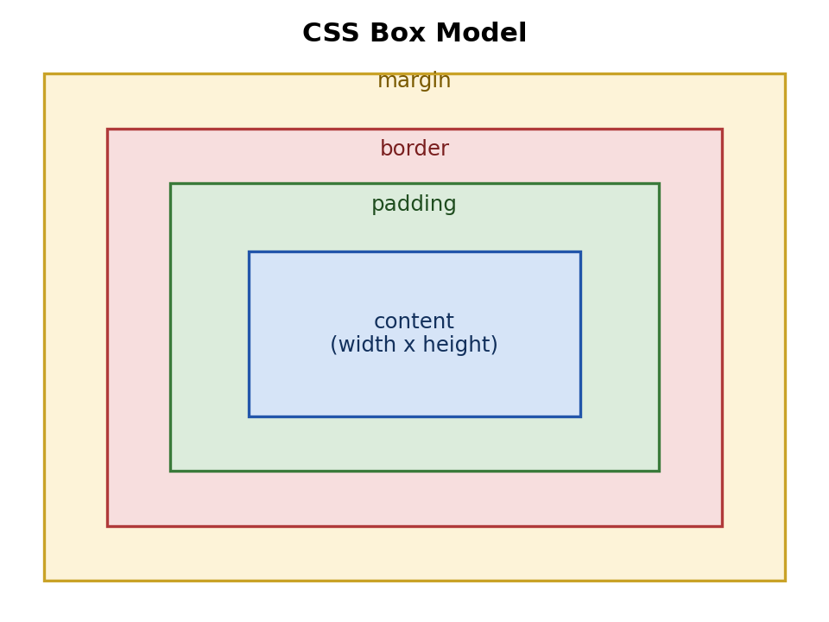
Every element = content + padding + border + margin. Get this backwards and your spacing/sizing will never match the mockup.

5.2 Flexbox Axes
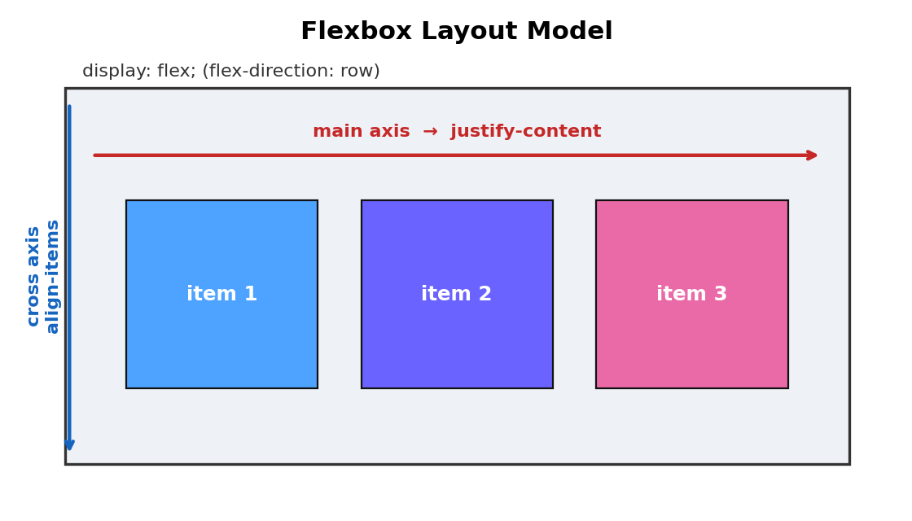
justify-content controls the MAIN axis; align-items controls the CROSS axis. Switch axes with flex-direction.

5.3 CSS Grid
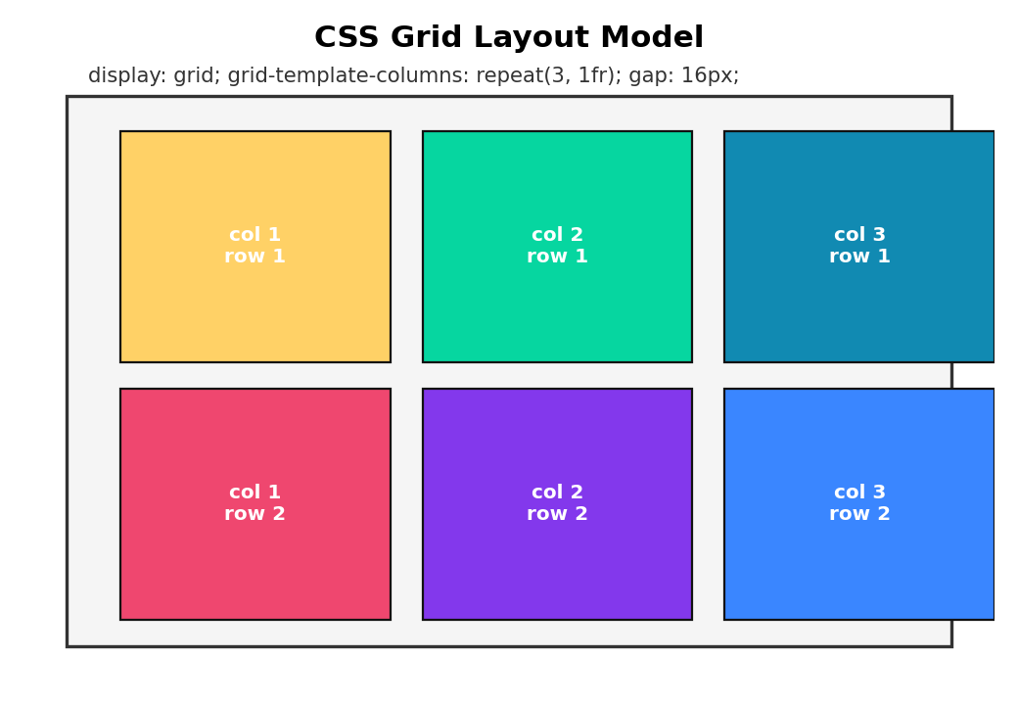
grid-template-columns defines column tracks; gap spaces cells without extra margin hacks.

Part 6 — "Web Mid Fall25" Paper: Fully Solved
Full working index.html + style.css files for both questions are delivered alongside this guide (Web Mid Fall25 Question 1 (Solution) and Question 2 (Solution) folders). Below is the solved breakdown and key code.

6.1 Question 1 — "ProConnect" Landing Page (15 marks)
Mockup requirements decoded from the annotated screenshot:
Element | Hex Color | Applied To
#3F46A4 | Indigo/blue | "ProConnect" logo text, "Start Your Free Trial" heading, Watch Demo button border+text
#EFF6FE | Light blue | Right-panel (sign-up form) background
#ECEFF4 | Light grey-blue | Whole page background
#50AD50 | Green | Feature checkmarks + "Learn More" button background
#71ADEC | Sky blue | "Real-time Collaboration" link text
#6FB570 | Muted green | "Create Account" button background + "Login Here" link
#FEFEFE | Off-white | "Create Account" button text color
Structure used: a flex navbar, then a two-column flex .hero (left = pitch copy + feature checklist + 2 buttons; right = a shaded .hero-right panel containing the sign-up form). Key snippet:
.hero { display: flex; gap: 40px; background: #fff; border-radius: 10px; padding: 40px; }
.hero-left { flex: 1.1; }
.hero-right { flex: 1; background: #EFF6FE; border-radius: 8px; padding: 30px; }
.check { width: 18px; height: 18px; background: #50AD50; border-radius: 4px;
display: inline-flex; align-items: center; justify-content: center; }
.btn-create { background: #6FB570; color: #FEFEFE; border: none;
padding: 12px; border-radius: 6px; font-weight: 700; }
Result: matches the mockup's card layout, color placement, and button hierarchy (filled green primary CTA vs. outlined secondary CTA).

6.2 Question 2 — Admin Dashboard (15 marks)
Mockup requirements decoded:
Element | Hex Color | Applied To
#536FFE | Indigo/blue | Avatar circles (topbar + profile card) + Project Completion bar fill
#C1CDFF | Lavender | "Home" active nav link + "Design" tag pill + its progress bar
#EBEBEB | Light grey | Main content-area background
#F93536 | Red | Overall Rating progress bar fill
#9EFE1E | Lime green | "Plan" tag pill + its progress bar
#FEBD57 | Orange | "Development" tag pill + its progress bar
Structure used: a full-width topbar (brand + nav + user block), then a shaded .content area holding a CSS Grid "top-grid" (profile card + 3 stat cards) and a 3-column "project-grid" of cards, each with a tag pill + labeled progress bar. Key snippet:
.top-grid { display: grid; grid-template-columns: 1.4fr 1fr 1fr 1fr; gap: 18px; }
.bar-track { background: #eee; height: 8px; border-radius: 4px; overflow: hidden; }
.bar-fill { height: 100%; border-radius: 4px; }
.fill-blue { background: #536FFE; } /* width set inline per item, e.g. style="width:80%" */
.tag { display: inline-block; padding: 4px 12px; border-radius: 12px; font-size: 12px; }
.tag-design { background: #C1CDFF; color: #2c3aa0; }
Note the reusable pattern: a .bar-track (grey groove) containing a .bar-fill (colored, inline width:X%) is the standard technique for every progress bar seen across all 5 papers — memorize this once and reuse it every time.

6.3 Rendered Result Preview
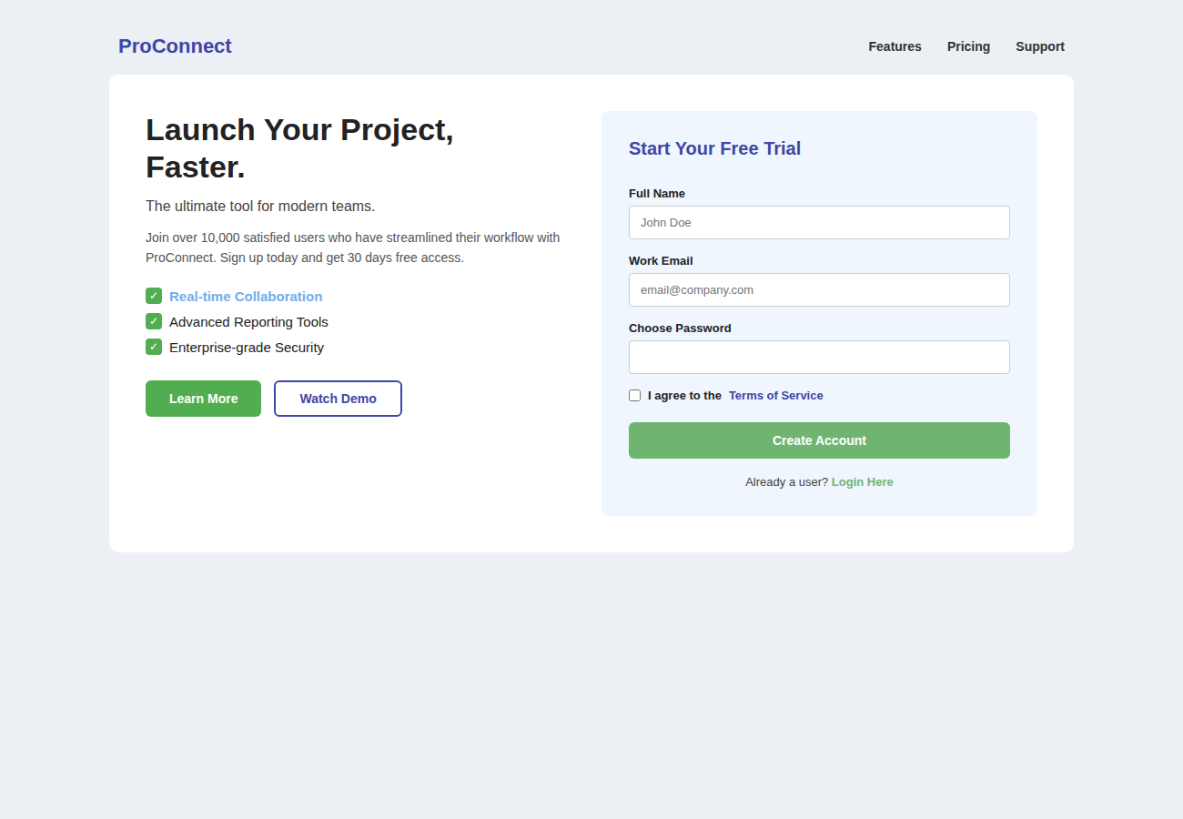
Fall'25 Question 1 rendered output (ProConnect landing page).
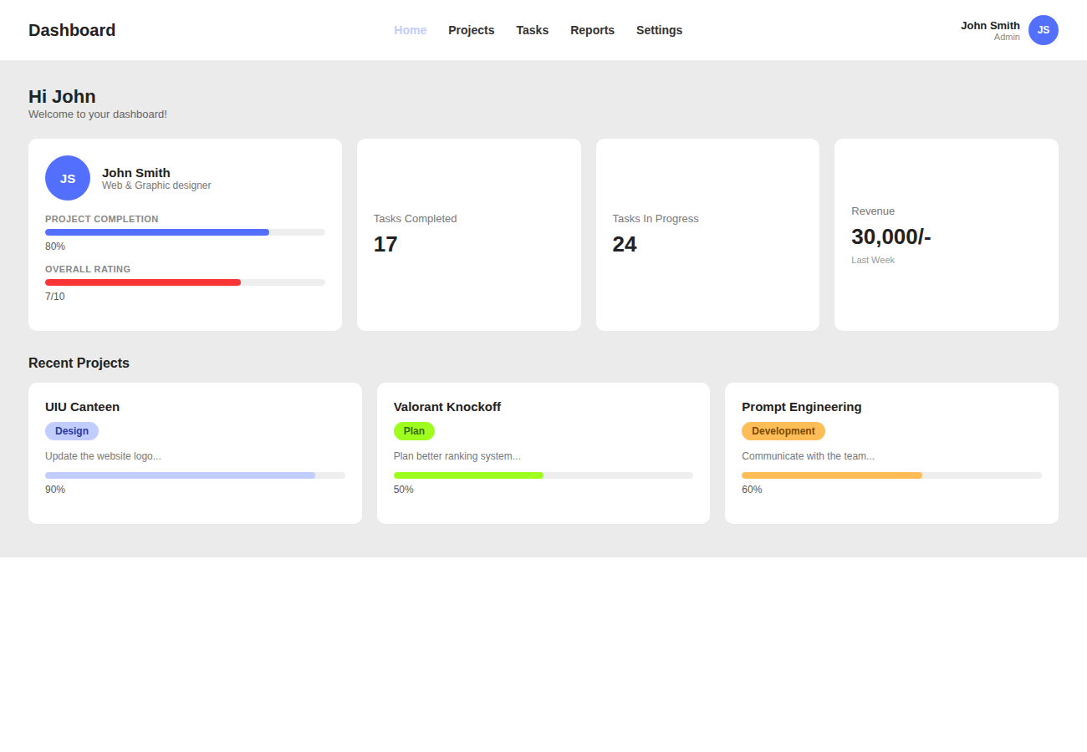
Fall'25 Question 2 rendered output (Admin dashboard).

Part 7 — Step-by-Step Strategy for ANY Question
Follow this exact sequence in the 90-minute exam (allot ~40–45 min per question):
Step | What To Do
1. Scan & annotate (2 min) | Identify the big regions first: navbar? sidebar? hero/split-screen? card grid? Sketch a box outline on paper/mentally before typing anything.
2. Write the HTML skeleton (8–10 min) | header/nav → main/section wrapper → repeat card/item blocks. Use placeholder text/numbers exactly as shown. Don't style yet — get structure 100% right first.
3. Reset & base styles (2 min) | Always start style.css with * { margin:0; padding:0; box-sizing:border-box; } then body { font-family: Arial, Helvetica, sans-serif; }.
4. Outer layout (5 min) | Apply display:flex or display:grid to the top-level containers (navbar row, split panels, sidebar+content) before touching inner components.
5. Component-by-component styling (15–20 min) | Style one card/section fully (bg, padding, radius, text) before copying the pattern to siblings. Apply exact hex codes as annotated in the mockup.
6. Spacing pass (5 min) | Walk through and fix gaps/margins/padding until proportions visually match — this is where most marks are lost/gained.
7. Interactivity polish (2 min) | Add cursor:pointer and :hover states to every link/button — low effort, expected by graders.
8. Responsive breakpoint (3 min) | Add one @media (max-width: 800–900px) block: stack flex rows to column, collapse grid to 1fr, hide/wrap nav.
9. Final visual check (3 min) | Open in browser (or mentally re-trace) and compare region-by-region against the mockup screenshot.

7.1 Common Pitfalls That Cost Marks
- Forgetting box-sizing:border-box — padding then breaks your intended widths.
- Hardcoding pixel widths everywhere instead of flex:1 / max-width — layout breaks on resize.
- Skipping the semantic tags (using all <div>) — many rubrics give small marks for header/nav/main/section/footer usage.
- Ignoring the annotated hex codes and "eyeballing" colors — exact hex match is often explicitly graded.
- No @media query at all — nearly every solved paper includes one, so omitting it is an easy lost mark.
- Not wrapping button text/icons consistently — keep a consistent .btn-* naming convention so grading is easy to follow.

Part 8 — Reusable Component Templates
These are the exact skeletons behind every past paper. Memorize the shapes — swap colors/text on exam day.

8.1 Navbar (appears in 10/10 questions)
<header class="topbar">
<div class="brand">SiteName</div>
<nav class="nav-links"><a href="#">Home</a><a href="#">About</a></nav>
<a href="#" class="btn-cta">Sign Up</a>
</header>
.topbar { display: flex; align-items: center; justify-content: space-between;
padding: 16px 40px; }
.nav-links { display: flex; gap: 24px; }

8.2 Card Grid (appears in 9/10 questions)
<section class="card-grid">
<div class="card">...</div>
<div class="card">...</div>
</section>
.card-grid { display: grid; grid-template-columns: repeat(3, 1fr); gap: 20px; }
/* OR for uneven/variable-width cards: */
.card-grid { display: flex; flex-wrap: wrap; gap: 20px; justify-content: center; }
.card { background: #fff; border-radius: 8px; padding: 20px; }

8.3 Sidebar + Content Layout (appears in 5/10 questions)
<div class="app"> <!-- or .layout -->
<aside class="sidebar">...</aside>
<main class="content">...</main>
</div>
.app { display: flex; min-height: 100vh; }
.sidebar { width: 240px; flex-shrink: 0; background: #1c3a6e; color: #fff; }
.content { flex: 1; padding: 30px 40px; }

8.4 Progress / Stat Bar (appears in 3/10 questions)
<div class="bar-track"><div class="bar-fill" style="width: 80%;"></div></div>
.bar-track { background: #eee; height: 8px; border-radius: 4px; overflow: hidden; }
.bar-fill { height: 100%; background: #536FFE; border-radius: 4px; }

8.5 Sign-in / Split Auth Screen
<main class="split">
<section class="panel-left">quote / testimonial</section>
<section class="panel-right">
<form class="signin-form">
<input type="email" placeholder="Email">
<input type="password" placeholder="Password">
<button type="submit">Sign In</button>
</form>
</section>
</main>
.split { display: flex; min-height: 100vh; }
.panel-left, .panel-right { width: 50%; padding: 60px 80px; }

8.6 Data Table (appears in 2/10 questions)
<table class="data-table">
<thead><tr><th>Course</th><th>Code</th><th>Credit</th></tr></thead>
<tbody><tr><td>Web Programming</td><td>CSE201</td><td>3.0</td></tr></tbody>
</table>
.data-table { width: 100%; border-collapse: collapse; }
.data-table th { background: #333; color: #fff; text-align: left; padding: 10px 14px; }
.data-table td { padding: 10px 14px; border-top: 1px solid #eee; }

8.7 Tag / Badge Pill (appears in 4/10 questions)
<span class="tag tag-blue">Full-time</span>
.tag { display: inline-block; padding: 4px 12px; border-radius: 14px;
font-size: 12px; font-weight: 600; }
.tag-blue { background: #e2ebfa; color: #205bcb; }

8.8 Avatar Circle (appears in 3/10 questions)
<div class="avatar">JS</div>
.avatar { width: 40px; height: 40px; border-radius: 50%; background: #536FFE;
color: #fff; display: flex; align-items: center; justify-content: center; }

Part 9 — One-Page Final Quick Reference
The absolute minimum you must have memorized cold before walking into the exam.

Always start every style.css with:
* { margin: 0; padding: 0; box-sizing: border-box; }
body { font-family: Arial, Helvetica, sans-serif; color: #222; }
a { text-decoration: none; color: inherit; }

The 6 layout properties that solve 90% of mockups:
Property | One-line meaning
display: flex; | Row/column layout for direct children
justify-content | Main-axis alignment (space-between is very common in navbars)
align-items: center; | Cross-axis alignment — vertically centers nav items
display: grid; grid-template-columns: repeat(N, 1fr); | Equal-width card grids
gap: 20px; | Spacing between flex/grid children, no manual margins needed
flex: 1; | Make an item grow to fill leftover space (e.g. sidebar's sibling content area)

Checklist before submitting:
- Semantic tags used (header/nav/main/section/aside/footer)?
- Every mockup hex color applied to the correct element?
- Flexbox/Grid used for every layout row/column (no floats)?
- border-radius, box-shadow, and spacing roughly match the screenshot?
- :hover added to links/buttons?
- At least one @media (max-width: ...) breakpoint present?
- File linked correctly: <link rel="stylesheet" href="style.css"> and filenames are index.html / style.css?

End of Guide — practiced correctly, this covers every pattern observed across Spring'25, Summer'25, Spring'26 (both slots), and Fall'25.

